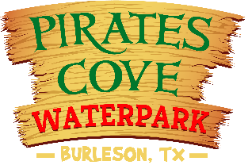
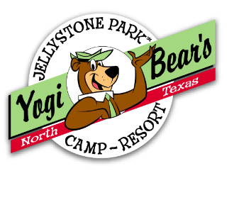

North Texas Jellystone Park
& Pirates Cove Water Park Burleson, Texas

Date:________________
EMPLOYMENT INQUIRY

Please Print Clearly. Please answer all questions. Resumes are not to be submitted in lieu of this form.
We are an equal opportunity employer. Applicants are considered for positions without regard to race, religion, sex, nation origin, age, disability, or any other consideration made unlawful by applicable federal, state, or local laws.

DEPARTMENTS: INDICATE IN THE BOX THE ORDER BY NUMBER WITH #1 BEING YOUR FIRST CHOICE, THE DEPARTMENT(s) FOR WHICH YOU ARE INTERESTED IN WORKING:
Activities Reservations Office Birthday Pal Housekeeping
Food Services Fun Zone (Arcade) Park Services Security
Maintenance Lifeguard Guest Entertainment

PERSONAL INFORMATION

NAME(LAST NAME FIRT) | PHONE NUMBER:
PRESENT ADDRESS | CITY,STATE,ZIP
EMAIL ADDRESS

Are you 16 years of age, or older? Yes No

Highest level of education completed ________________________________________

GENERAL INFORMATION
LIST SPECIAL/TECHNICAL SKILLS, OR SKILLS YOU FEEL QUALIFY YOU FOR THE POSITION IN WHICH YOU ARE INTERESTED. :

APPLICANT SIGNATURE: _________________________________Date: _________

